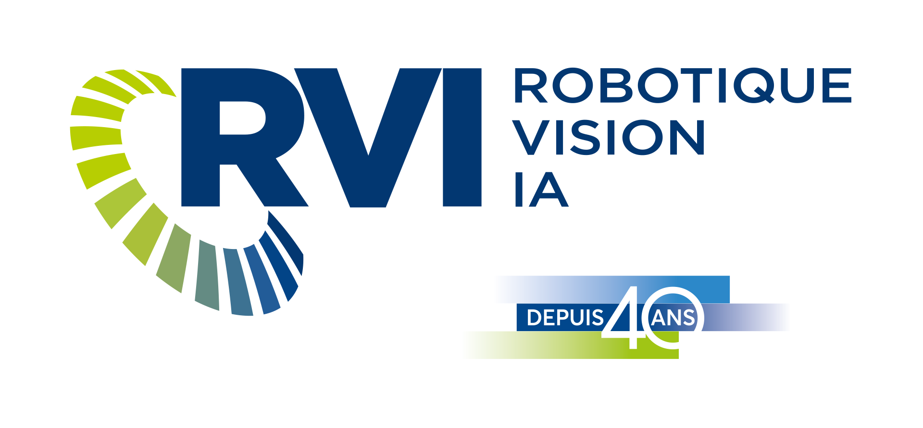 | PRESS RELEASE  FOR IMMEDIATE RELASES

CRVI Designated as a Technology Access Centre (TAC) in Advanced Robotics

Lévis, June 19, 2025 – The Centre de robotique et de vision industrielles inc. (CRVI) has reached a major milestone by being officially recognized as a Technology Access Centre (TAC) specializing in advanced robotics. This prestigious designation, granted by the Natural Sciences and Engineering Research Council of Canada (NSERC), was announced during CRVI’s Annual Advanced Robotics and Artificial Intelligence Symposium, which brought together over 100 participants passionate about the future of industry.

“This designation as a Technology Access Centre is a tremendous recognition that strengthens our mission across Canada,” said Marie-Christine Ferland, Executive Director of CRVI. “It provides us with enhanced means to meet the innovation needs of local businesses. We are eager to deepen our collaborations to develop robotic solutions that boost the competitiveness and efficiency of our partners.”

A Strategic Response to Today’s SME Challenges
In an economic context where many Canadian SMEs operate with a wide variety of products in relatively low volumes (high-mix, low-volume), this designation comes at a perfect time. The need to adopt flexible, adaptable, and intelligent technologies has never been more urgent. With its expertise in advanced, traditional, collaborative, and mobile robotics, digital vision, artificial intelligence, digital twins, and software development, CRVI positions itself as a central player in the digital transformation of these businesses.

A Strategic Shift Toward Advanced Robotics
Since 2019, CRVI has identified advanced robotics as a key development priority. This direction materialized through the launch of a $2 million internal research program over five years, along with a plan for investment in robotic infrastructure. This program has allowed CRVI to enhance its traditional expertise in robotics and vision by integrating artificial intelligence and software development dedicated to robotic applications.

The results are already tangible: several SMEs have increased their productivity, automated complex operations, and accessed customized solutions tailored to their manufacturing realities.

About CRVI
A key innovation player in Quebec for over 40 years, CRVI is a Technology Access Centre (TAC) specializing in advanced robotics, digital vision, and artificial intelligence. Its mission is to support business growth by offering applied research services, technology transfer, and guidance toward Industry 4.0 and 5.0. A proud member of the Synchronex CCTT Network, CRVI relies on a multidisciplinary team and cutting-edge infrastructure to generate maximum value for its clients.

-30-
Marie-Christine Ferland
General Manager, CRVI
marie-christine.ferland@cegeplevis.ca
Office : (418) 833-1965, ext. 3261
Mobile : (418) 473-1278

